**LOG ANALYSIS**

System Requirements:

Hadoop Ecosystems : Hadoop 1.x, HIVE, HBASE, Map Reduce

Programming Language : Java

Query Languages : Hive, HBase

Operating System : CentOS-5

Work Flow Diagram:

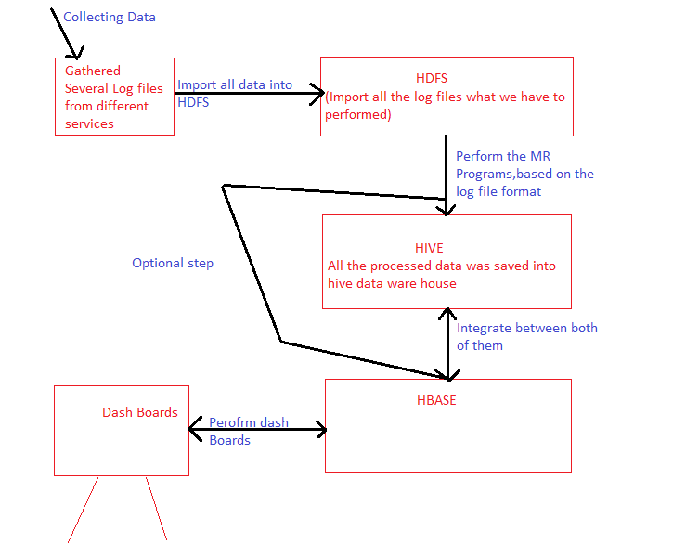

Description:

We have to write the Map Reduce code for the separation of filtering the log files by the comma separate ( , ) based on the log files format.

After the MapReduce code separate log files, will be placed into the hive Data Warehouse

(for HIVE we may have to use the Mysql)

After the data saved into hive placed the same data into the Hbase by using Hive and Hbase integration.

So we can expose the data into Dash-Boards by using Hive and HBase.